Digital Logic

Logic Tables and Gate Combinations

Authored by xor

evilzone.org

# DIGITAL LOGIC PRIMER

If you are unsure what Digital Logic is, please view the first tutorial in this series, ‘Digital Logic Primer’.

This should give you all the information you need to continue on with this tutorial.

<https://github.com/XorLogic/DigitalLogic>

# TRUTH TABLES – REVISITED

Truth tables are an essential part of describing the behaviour of digital circuits.

They list all the possible combinations of inputs, and the expected outputs for each input combination.

While it might be intuitive and easy to create a digital logic circuit containing only one input and one output, the circuit gets more complicated as inputs and outputs are added.

Below are a few examples of truth tables. You will learn how to build these in the following sections.

|  |  |
| --- | --- |
| **Input A** | **Output** |
| 0 | 0 |
| 1 | 1 |

|  |  |
| --- | --- |
| **Input A** | **Output** |
| 0 | 1 |
| 1 | 0 |

|  |  |  |
| --- | --- | --- |
| **Input A** | **Input B** | **Output** |
| 0 | 0 | 0 |
| 0 | 1 | 0 |
| 1 | 0 | 0 |
| 1 | 1 | 1 |

|  |  |  |  |
| --- | --- | --- | --- |
| **Input A** | **Input B** | **Output A** | **Output B** |
| 0 | 0 | 0 | 0 |
| 0 | 1 | 1 | 0 |
| 1 | 0 | 1 | 0 |
| 1 | 1 | 0 | 1 |

# BUILDING TRUTH TABLES

When we break down a digital circuit, each element will be one of those described below. In order to build truth tables from these elements, we need to follow a few basic steps.

|  |  |  |
| --- | --- | --- |
| **Type** | **Description** | **Schematic Symbol** |
| **INPUT** | Something that defines the starting signal. |  |
| **OPERATION (GATE)** | Something that you do with the signal. |  |
| **OUTPUT** | What the signal looks like after the operation. |  |

## DEFINE INPUTS

When you are designing a circuit for a specific purpose you will be able to derive how many inputs you are expecting (as shown later), but for now, let’s say we want to do some operation on two inputs. Then we will list all the possible combinations for these inputs.

|  |  |  |
| --- | --- | --- |
| **Input A** | **Input B** |  |
| 0 | 0 |
| 0 | 1 |
| 1 | 0 |
| 1 | 1 |

## DEFINE OPERATIONS

Then we decide which operation we want to perform on those inputs. In this instance, we will do an AND operation.

|  |  |  |  |
| --- | --- | --- | --- |
| **Input A** | **Input B** | **Operation**  **A AND B** |  |
| 0 | 0 | 0 AND 0 |
| 0 | 1 | 0 AND 1 |
| 1 | 0 | 1 AND 0 |
| 1 | 1 | 1 AND 1 |

## DEFINE OUTPUTS

The schematic diagram shows us that the AND gate only has one OUTPUT. If we learned anything from the Digital Logic Primer, we know that the OUTPUT will only be HIGH (1) when BOTH INPUTS are HIGH. Otherwise the OUTPUT will be LOW.

|  |  |  |  |
| --- | --- | --- | --- |
| **Input A** | **Input B** | **Output** |  |
| 0 | 0 | 0 |
| 0 | 1 | 0 |
| 1 | 0 | 0 |
| 1 | 1 | 1 |

# BUILDING TRUTH TABLES – COMBINED LOGIC

Using this same method as above, we can add more inputs, or more operations which will give us more outputs.

Building on the previous example, if we throw an OR Gate in the circuit, you’ll see that we have added another OUTPUT. You will also see that we re-used the same inputs

|  |  |  |  |
| --- | --- | --- | --- |
| **Input A** | **Input B** | **Output A**  **A AND B** | **Output B**  **A OR B** |
| 0 | 0 | 0 | 0 |
| 0 | 1 | 0 | 1 |
| 1 | 0 | 0 | 1 |
| 1 | 1 | 1 | 1 |

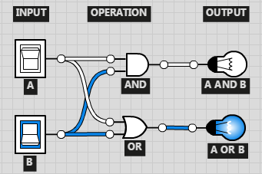

# FURTHER LEARNING – SELF TESTING

Head on over to <http://logic.ly/demo/> and see if you can create this simple logic circuit.

|  |  |  |  |
| --- | --- | --- | --- |
| **Input A** | **Input B** | **Output A**  **A ? B** | **Output B**  **A ? B** |
| 0 | 0 | 0 | 0 |
| 0 | 1 | 1 | 0 |
| 1 | 0 | 1 | 0 |
| 1 | 1 | 0 | 1 |

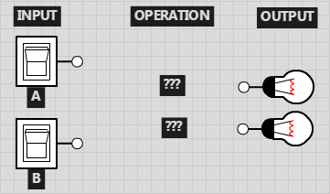

# Summary Notes

This tutorial should have demonstrated how digital logic and truth tables are closely tied together and how adding multiple logic gates can produce more advanced circuits.

If you successfully managed to create the circuit in the Further Learning section, congratulations!

You just made a Half-Adder circuit!

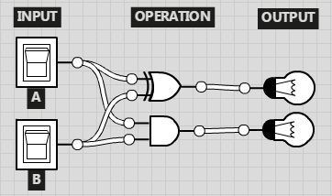

**Half adder**

[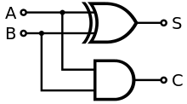](http://en.wikipedia.org/wiki/File:Half_Adder.svg)

Half adder logic diagram

The half adder adds two single binary digits *A* and *B*. It has two outputs, sum (*S*) and carry (*C*). The carry signal represents an overflow into the next digit of a multi-digit addition. The value of the sum is 2*C* + *S*. The simplest half-adder design, pictured on the right, incorporates an [XOR gate](http://en.wikipedia.org/wiki/XOR_gate) for *S* and an [AND gate](http://en.wikipedia.org/wiki/AND_gate) for *C*. With the addition of an OR gate to combine their carry outputs, two half adders can be combined to make a full adder.[[1]](http://en.wikipedia.org/wiki/Adder_%28electronics%29#cite_note-1)

The half adder adds two input bits and generates a carry and sum, which are the two outputs of a half adder. The input [variables](http://en.wikipedia.org/wiki/Variable_(computer_science)) of a half adder are called the augend and addend bits. The output variables are the sum and carry. The [truth table](http://en.wikipedia.org/wiki/Truth_table) for the half adder is:

<http://en.wikipedia.org/wiki/Adder_%28electronics%29#Half_adder>

If you have any questions, or would like to post me your results of the further learning page, please feel free to PM me your results on the forums.

Happy learning!

-- xor